6. HQL: Named & Positional Parameters, Aggregate Functions, Sorting & Paging, HQL Vs HCQL

HQL (Hibernate Query Language)
- HQL is an object-oriented query language
- It works on Entity class names and properties, not database tables
- Database-independent (Hibernate converts HQL → SQL)
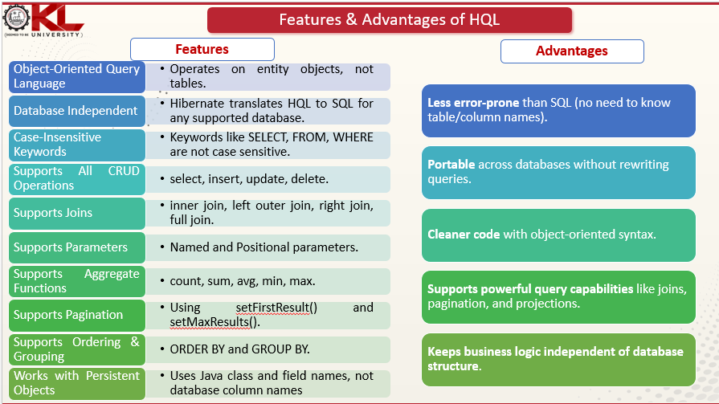

HQL Parameters
Parameters are used to pass values dynamically to queries (prevents SQL injection).

A) Positional Parameters
- Identified by ? followed by index (starting from 0 or 1 depending on version)
- Older style (less readable)
Example:
- Query q = session.createQuery("FROM Student WHERE marks > ?0" ); q.setParameter(0, 75);
Disadvantage: Hard to read and maintain.

B) Named Parameters
- Identified by :name
- Recommended and widely used
Example:
Query q = session.createQuery(
"FROM Student WHERE department = :dept"
);
q.setParameter("dept", "CSE");
📌 Advantages:
- More readable
- Order does not matter
- Easy maintenance

3. Aggregate Functions in HQL
Used to perform calculations on data.

Common Aggregate Functions
Function | Purpose
count() | Number of rows
sum() | Total
avg() | Average
min() | Minimum value
max() | Maximum value

Examples
Count students
SELECT count(s.id) FROM Student s
Average marks
SELECT avg(s.marks) FROM Student s
Maximum salary
SELECT max(e.salary) FROM Employee e
📌 Aggregate functions return single values, not objects.

4. Sorting in HQL (ORDER BY)
Used to arrange results.

Syntax
FROM Entity ORDER BY property ASC|DESC

Examples
Ascending order
FROM Student ORDER BY name ASC
Descending order
FROM Student ORDER BY marks DESC
Multiple columns
FROM Student ORDER BY department ASC, marks DESC

5. Paging (Pagination) in HQL
Used to fetch data in chunks (important for large data).

Methods Used
- setFirstResult(int)
- setMaxResults(int)

Example (Fetch records 11–20)
Query q = session.createQuery("FROM Student");
q.setFirstResult(10); // starting index
q.setMaxResults(10); // number of records
📌 Used in:
- Web applications
- Reports
- Data tables

6. HQL vs HCQL (Criteria API)
Feature | HQL | HCQL (Hibernate Criteria Query Language)
Type | String-based | Object-based
Syntax | SQL-like | Java API
Readability | High | Medium
Compile-time check | ❌ No | ✅ Yes
Dynamic queries | Difficult | Easy
Deprecated status | Active | Older Criteria is deprecated (JPA Criteria preferred)

HQL Example
FROM Student WHERE marks > 80

HCQL (Criteria) Example
Criteria c = session.createCriteria(Student.class);
c.add(Restrictions.gt("marks", 80));
📌 When to use what?
- HQL → Simple, readable queries
- HCQL / Criteria → Dynamic queries with conditions added at runtime

Project Structure:
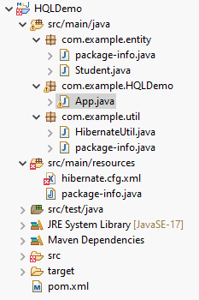

To create the xml file in Eclips do as follows:
Right Click on the package in which you want to create New → Other… XML → XML File

Open the MySQL:

Database Name (You can choose) : Let us assume the database name is: studentdb
Execute the following commands in the MYSQL:
SELECT * FROM studentdb.student;
use studentdb;
INSERT INTO student (name, department, marks) VALUES
('Ravi', 'CSE', 85),
('Anita', 'ECE', 72),
('Kiran', 'CSE', 90),
('Suma', 'MECH', 65),
('Arjun', 'CSE', 78);
SELECT * FROM studentdb.student;
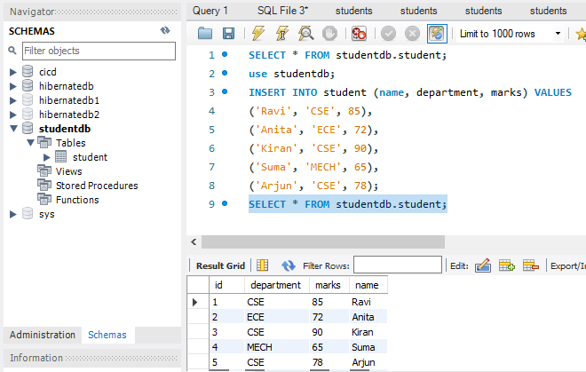
======================================================================

=======================================================
Entity Class – Student.java
============================================
package com.example.entity;

import javax.persistence.*;

@Entity
@Table(name = "student")
public class Student {

@Id
@GeneratedValue(strategy = GenerationType.IDENTITY)
private int id;

private String name;
private String department;
private int marks;

// Constructors
public Student() {}

public Student(String name, String department, int marks) {
this.name = name;
this.department = department;
this.marks = marks;
}

// Getters & Setters
public int getId() { return id; }
public String getName() { return name; }
public String getDepartment() { return department; }
public int getMarks() { return marks; }
}
======================================================================
Hibernate Utility – HibernateUtil.java
***************************************************
package com.example.util;

import org.hibernate.SessionFactory;
import org.hibernate.cfg.Configuration;

import com.example.entity.Student;

public class HibernateUtil {

private static SessionFactory factory;

static {
factory = new Configuration()
.configure("hibernate.cfg.xml")
.addAnnotatedClass(Student.class)
.buildSessionFactory();
}

public static SessionFactory getSessionFactory() {
return factory;
}
}
==========================================================================
App.java
***********************************
package com.example.HQLDemo;

import java.util.List;
import org.hibernate.*;
import com.example.entity.Student;
import org.hibernate.criterion.Restrictions;

import com.example.util.HibernateUtil;

public class App {

public static void main(String[] args) {

Session session = HibernateUtil.getSessionFactory().openSession();
Transaction tx = session.beginTransaction();

/* -------------------------------
1. Named Parameter Example
-------------------------------- */
Query<Student> q1 = session.createQuery(
"FROM Student WHERE department = :dept", Student.class);
q1.setParameter("dept", "CSE");

List<Student> list1 = q1.list();
System.out.println("Students from CSE:");
list1.forEach(s -> System.out.println(s.getName()));

/* -------------------------------
2. Positional Parameter Example
-------------------------------- */
Query<Student> q2 = session.createQuery(
"FROM Student WHERE marks > ?0", Student.class);
q2.setParameter(0, 70);

List<Student> list2 = q2.list();
System.out.println("\nStudents with marks > 70:");
list2.forEach(s -> System.out.println(s.getName()));

/* -------------------------------
3. Aggregate Function Example
-------------------------------- */
Query<Long> q3 = session.createQuery(
"SELECT count(s.id) FROM Student s", Long.class);

Long count = q3.uniqueResult();
System.out.println("\nTotal Students: " + count);

/* -------------------------------
4. Sorting Example
-------------------------------- */
Query<Student> q4 = session.createQuery(
"FROM Student ORDER BY marks DESC", Student.class);

List<Student> sortedList = q4.list();
System.out.println("\nStudents Sorted by Marks:");
sortedList.forEach(s ->
System.out.println(s.getName() + " - " + s.getMarks()));

/* -------------------------------
5. Paging (Pagination) Example
-------------------------------- */
Query<Student> q5 = session.createQuery(
"FROM Student", Student.class);
q5.setFirstResult(0); // start index
q5.setMaxResults(3); // number of records

List<Student> pageList = q5.list();
System.out.println("\nFirst 3 Students:");
pageList.forEach(s -> System.out.println(s.getName()));

/* -------------------------------
6. HCQL (Criteria API) Example
-------------------------------- */
Criteria c = session.createCriteria(Student.class);
c.add(Restrictions.gt("marks", 80));

List<Student> criteriaList = c.list();
System.out.println("\nHCQL (Criteria) - Marks > 80:");
criteriaList.forEach(s -> System.out.println(s.getName()));

tx.commit();
session.close();
HibernateUtil.getSessionFactory().close();
}
}

======================================================================

hibernate.cfg.xml file
*******************************
<?xml version="1.0" encoding="UTF-8"?>
<!DOCTYPE hibernate-configuration PUBLIC
"-//Hibernate/Hibernate Configuration DTD 3.0//EN"
"http://hibernate.sourceforge.net/hibernate-configuration-3.0.dtd">

<hibernate-configuration>
<session-factory>

<!-- Database connection -->
<property name="connection.driver_class">com.mysql.cj.jdbc.Driver</property>
<property name="connection.url">jdbc:mysql://localhost:3306/studentdb</property>
<property name="connection.username">root</property>
<property name="connection.password">root</property>

<!-- Hibernate settings -->
<property name="dialect">org.hibernate.dialect.MySQL8Dialect</property>
<property name="show_sql">true</property>
<property name="hbm2ddl.auto">update</property>

<!-- Mapping -->
<mapping class="com.example.entity.Student"/>

</session-factory>
</hibernate-configuration>

POM.XML file

<dependencies>

<!-- Hibernate Core -->

<dependency>

<groupId>org.hibernate</groupId>

<artifactId>hibernate-core</artifactId>

<version>5.6.15.Final</version>

</dependency>

<!-- MySQL Connector -->

<dependency>

<groupId>mysql</groupId>

<artifactId>mysql-connector-java</artifactId>

<version>8.0.33</version>

</dependency>

<!-- JPA API -->

<dependency>

<groupId>javax.persistence</groupId>

<artifactId>javax.persistence-api</artifactId>

<version>2.2</version>

</dependency>

<!-- Logging (Optional but recommended) -->

<dependency>

<groupId>org.slf4j</groupId>

<artifactId>slf4j-simple</artifactId>

<version>1.7.36</version>

</dependency>

</dependencies>

===============================================================================

Program Demonstrates (Quick Map)
Concept | Code Section
Named Parameter | :dept
Positional Parameter | ?0
Aggregate Function | count()
Sorting | ORDER BY marks DESC
Paging | setFirstResult(), setMaxResults()
HQL vs HCQL | HQL queries vs Criteria
================================

Run the Project from Eclipse
Right-click → Run As → Java Application
You will see SQL queries results will be printed in console as follows:
OUTPUT
Students from CSE:
Ravi
Kiran
Arjun

Students with marks > 70:
Ravi
Anita
Kiran
Arjun
Total Students: 5

Students Sorted by Marks:
Kiran - 90
Ravi - 85
Arjun - 78
Anita - 72
Suma - 65

First 3 Students:
Ravi
Anita
Kiran

HCQL (Criteria) - Marks > 80:
Ravi
Kiran

=================================================================

